1. In what modes should the PdfFileReader() and PdfFileWriter() File objects will be opened?

**Answer :**

PdfFileReader() needs to be opened in read-binary mode by passing 'rb'. And PdfFileWriter() needs to be opened in write-binary mode with 'wb'.

2. From a PdfFileReader object, how do you get a Page object for page 5?

**Answer :**

Calling getPage(4) will return a Page object for Page 5, since page 0 is the first page.

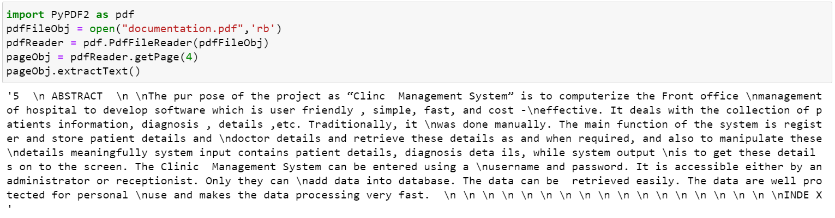

3. What PdfFileReader variable stores the number of pages in the PDF document?

**Answer :**

The numPages variable stores an integer of the number of pages in PdfFileReader object.

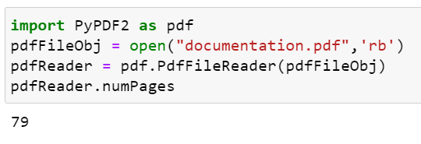

4. If a PdfFileReader object’s PDF is encrypted with the password swordfish, what must you do

before you can obtain Page objects from it?

**Answer :**

Before we obtain the page object, the pdf has to be decrypted by using .decrypt(‘swordfish’)

5. What methods do you use to rotate a page?

**Answer :**

rotateClockwise() and rotateCounterClockwise() are the methods that are called to rotate a page.

Degrees to rotate is passed as integer argument.

6. What is the difference between a Run object and a Paragraph object?

**Answer :**

Paragraph object – A document contains multiple paragraphs. A paragraph begins on a new line and contains multiple runs. A document object contains a list of paragraph objects for the paragraphs in the document. (A new paragraph begins when a user presses ENTER or RETURN while typing in a word document.)

Run object – Runs are contagious groups of characters within a paragraph with the same style.

7. How do you obtain a list of Paragraph objects for a Document object that’s stored in a variable

named doc?

**Answer :**

By using doc.paragraphs

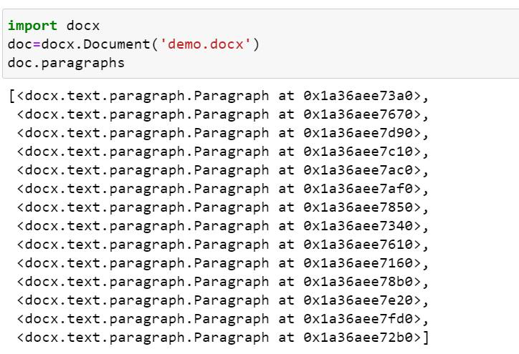

8. What type of object has bold, underline, italic, strike, and outline variables?

**Answer :**

A Run object has bold, italic, underline, strike and outline variables.

9. What is the difference between False, True, and None for the bold variable?

**Answer :**

Run can be styled by using text attributes. Each attribute can be set to one of the three values:

1. False – It is always disabled.
2. True – It is always enabled, no matter what other styles are applied to run.
3. None – Defaults to whatever style Run is set to.

10. How do you create a Document object for a new Word document?

**Answer :**

By calling docx.Document() function.

11. How do you add a paragraph with the text ‘Hello, there!’ to a Document object stored in a variable named doc?

**Answer :**

doc.add_paragraph(‘Hello, there!’)

12. What integers represent the levels of headings available in Word documents?

**Answer :**

Integers from 0 to 4 represents the levels of headings available in word documents. 0 makes the title and 1 to 4 are different heading levels, where 1 being main heading and 4 is the lowest subheading.

The arguments to add_heading() are a string of the heading text and an integer from 0 to 4.